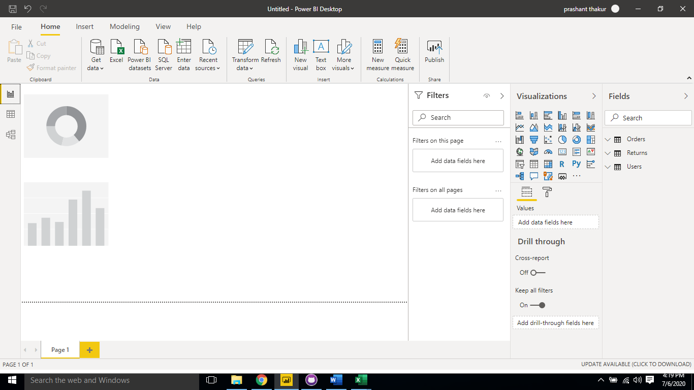

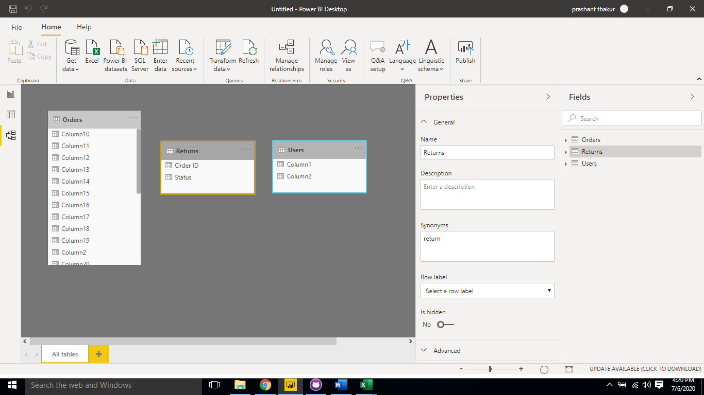

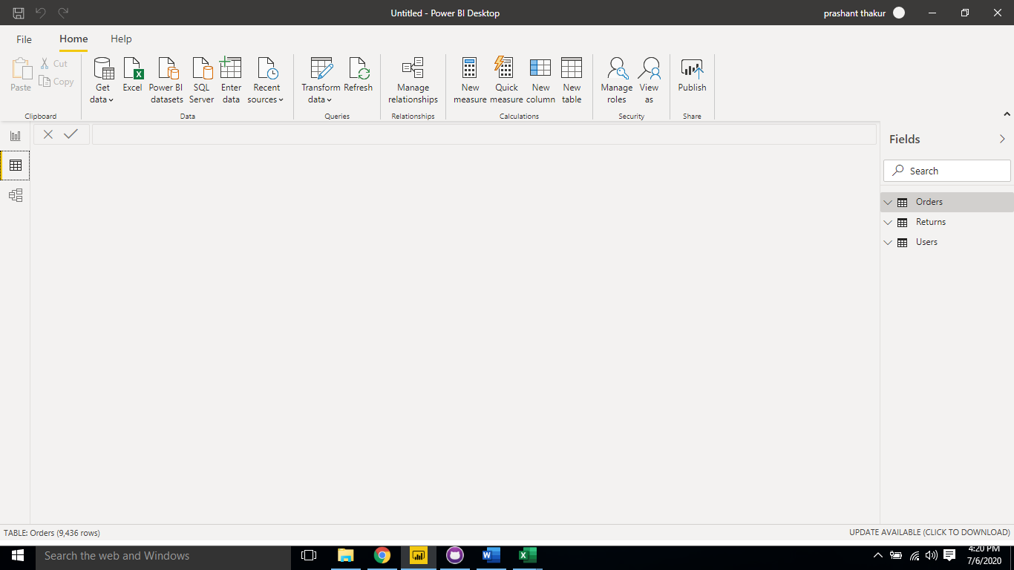

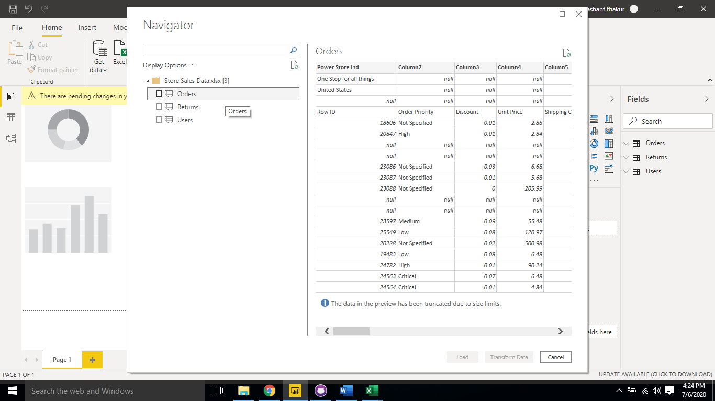

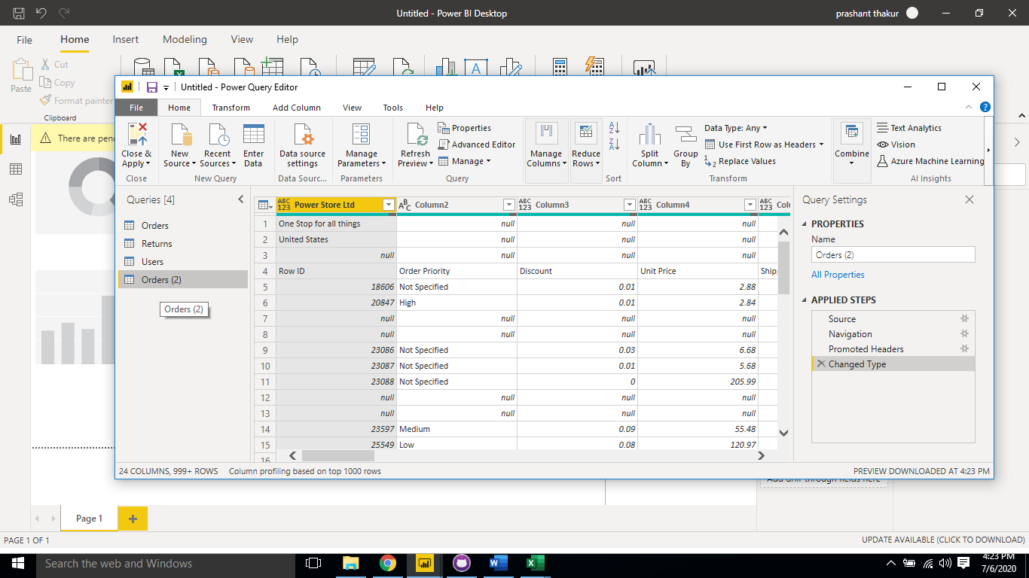

comparison between desktop and pro and premium

Power BI Desktop

Power BI Desktop is the free version of Power BI that you can install on your local computer as a program, and acts as a companion desktop application to the full version of Power BI. If you need to consolidate your data sources, create your own reports and conduct your own analysis.

Power BI Pro

Power BI Pro is the full version of Power BI, complete with the ability to use Power BI for both building dashboards and reports and unlimited viewing, sharing and consumption of your created reports (and reports shared by others) - the latter not possible with Power BI Desktop.
A breakdown of Power BI Pro’s differences against Power BI Desktop:
- Ability to embed Power BI visuals into apps (PowerApps, SharePoint, Teams, etc)
- Native integration with other Microsoft solutions (Azure Data Services)
- Share datasets, dashboards and reports with other Power BI Pro users
- Can create App Workspaces and peer-to-peer sharing

Power BI Premium

Power BI Premium is the most expensive tier of Power BI currently available and very distinct from the other two versions available on the market.
On top of the features and functionality standard to all versions of the service, users of Power BI Premium get:
- Increased data capacity limits and maximum performance
- Access to one API surface
- Ability to embed Power BI visuals into apps (PowerApps, SharePoint, Teams, etc)
- Larger storage sizes for extended deployments
- Geo distribution, higher refresh rates, isolation, pin to memory, read-only replicas
- Power BI Report Server
Power BI Premium differs from the free version and Power BI pro in its licensing model, which only suits a specific size and type of organisation and business scenario. You can purchase Premium in a range of capacity sizes that offer different numbers of memory and virtual cores that can scale as your data analysis requirements change.

